Python Modules
Socket modules in python
The socket module is Python's built-in networking library. It allows programs to communicate with other computers over a network using protocols like TCP and UDP.
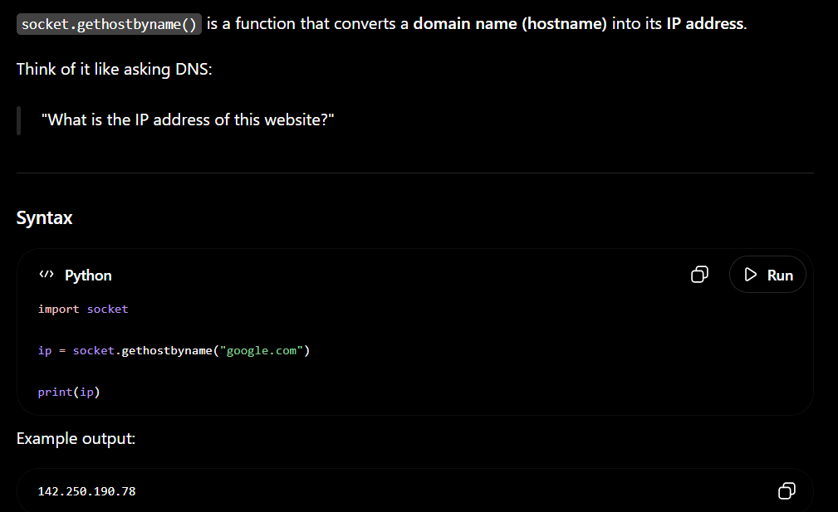
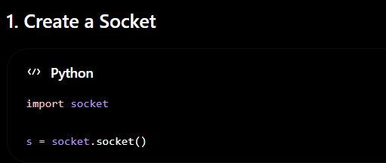
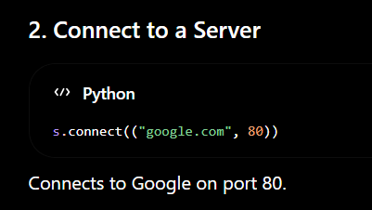
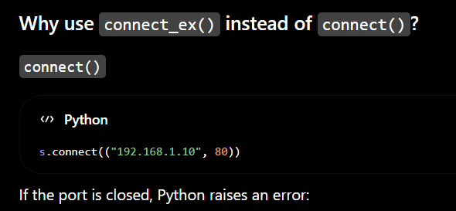
When it returns 0 the connection is successful:
conn = s.connect_ex((target, port))
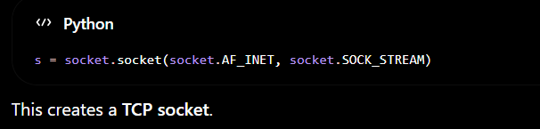

socket.AF_INET => this means it is using IPV4
socket.SOCK_STREAM => this means that use TCP protocol
Threading modules in python
